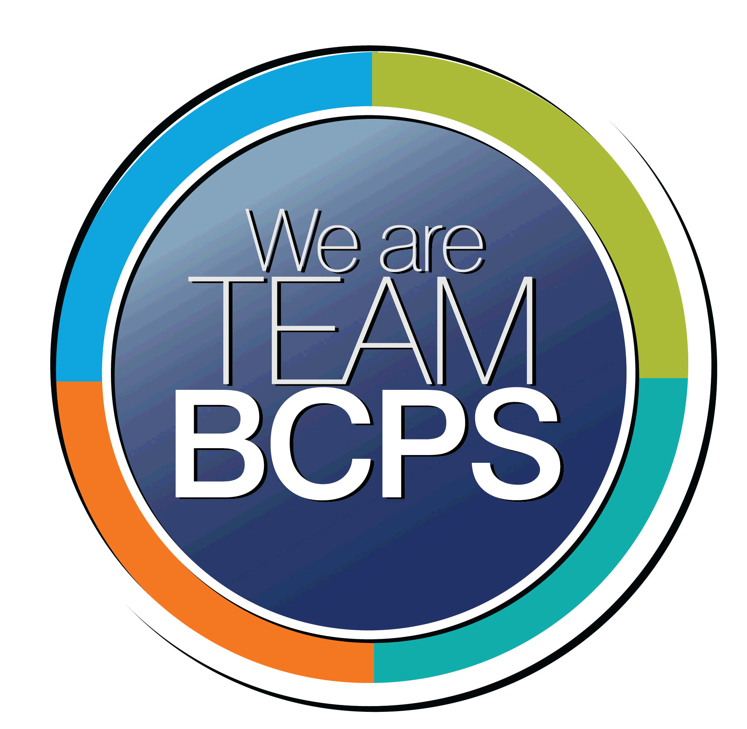 **Schoolwide Positive Behavior Plan** 

**Baltimore County Public Schools**

**Date Completed: 12/8/2021 School Year 2021-2022**

**School: Deer Park Elementary School**

|  |
| --- |
| **Section 1: Initial Steps** |
|  |
| **School Climate Team** |
| *Identify members of a School Climate Team (consider a representative selection of members). The team meets initially to examine equity concerns and data and to develop the Schoolwide Positive Behavior Plan. The team should then meet monthly (minimum quarterly) to assess the effectiveness of the SWPBP on an ongoing basis.* |
| Renee Jenkins, Principal  Katie Fridley, Assistant Principal  Kirsten Chalk, Vocal Music (Special Area)  Sherri Sweren, Kindergarten  Shelby Andresen, First Grade  Megan Swauger, Third Grade  Julie Fortier, Fourth Grade,  Karin Carter, Fifth Grade  Patrice Bender, School Counselor  Kristen Vanneman-Gooding, School Nurse |
| **Equity Lens** |
| *Through an equity lens, identify what the data indicate about the social-emotional needs of students and the support provided by staff members relative to disproportionality between student groups, especially for African Americans or students receiving special education. Also consider the school’s population with regard to ELL, Latinx, and/or other student groups. (Information may be from School Data Story)* |
| School Demographics:  92% African American  1.5% Caucasian  .5% Asian  3.4% Hispanic  2.2% Multi Racial  .5% American Indian  The 2018-2019 Stakeholder Survey domain values were 80.8 for Academic Aspirations, 61.2 for Belonging, and 77.2 for Student Support. These results indicate that student perception has remained stable for Academic Aspirations, Belonging, and Student Support since 2017-2018. In 2018-2019, nearly two out of every five students indicated that they were bullied, and more than half of students reported witnessing bullying. Students reported most frequently experiencing bullying outside the classroom (cafeteria, gym, hallway, stairs) and witnessing bullying outside the classroom (cafeteria, gym, hallway, stairs). Across all domains and measures, where there are data for the non-binary student group, their perception of climate, specifically Belonging, are notably unfavorable than their peers. |
| **Data Analysis** |
| *Summarize what the data tell about the school climate. (Information from School Data Story)* |
| Suspension data revealed that FARMS students are suspended at higher rates than their non-FARMS peers. However, the gap has narrowed over time, indicating a positive trend.  The data also revealed that Special Education students are suspended at rates higher than their non-Special Education peers. The suspension rate gap has widened over time, indicating a negative trend. |
| **Climate Goals** |
| *Identify the school’s goals in improving the social-emotional climate of the building. (Information from School Progress Plan)* |
| Educators will build relational capacity through team building and collaborative activities to strengthen our professional learning community.  Opportunities for parents to participate in events where they can share culture and diversity. |
| **Section 2: Developing and Teaching Expectations** |
|  |
| **Expectations Defined** |
| *Identify a School Code of Conduct with 3-5 positively stated school expectations. Develop a way to communicate the identified rules, based on the schoolwide expectations, for specific settings within the school building. Expectations should be clearly stated, communicated, taught, and frequently referenced.* |
| Deer Park Elementary School’s Code of Conduct:  As a proud member of the Deer Park Elementary School Community, I will be:  Respectful of others  Responsible for my Behavior  Ready to Learn  The code of conduct is state every morning during morning announcements. Our school counselor provides daily messages with strategies students may use to ensure they are following the code of conduct no matter what may be going on emotionally.  We have a matrix that describes what respectful, responsible, and ready looks like in all aeras of the school i.e., classroom cafeteria, bathroom, recess, and on the bus. |
| **Classroom Plan for Teaching and Reinforcing Expectations, Routines, and Procedures** |
| *Teachers develop visuals to communicate culturally relevant classroom expectations, routines, and procedures based upon the schoolwide expectations. Educators explicitly teach expectations, routines, and procedures. The school staff recognize and reinforce expected and positive behavior. Teachers identify encouraging procedures and corrective procedures for their classrooms.* |
| Teachers will explicitly teach the expectations of the Code of Conduct using the matrix. The use of Positive Behavior Intervention strategies will be included in daily instruction. Revisit tickets and the prize cart. |
| **Family/Community Engagement** |
| *Identify how the Schoolwide Positive Behavior Plan, the schoolwide expectations, and/or interventions will be communicated and shared with families. Consider how to include family and student voice in the initial plan and in evaluating the plan throughout the year.* |
| Parent and Community Involvement:  -Back to School Night  -Parent Handbook  -Parent/Teacher Conferences  -Schoology Messenger  -Monthly school newsletter  -Stakeholder Survey  -Deer Park will post our SWPBP on our webpage. We will also include the plan in our Parent Handbook. |
| **Section 3: Developing Interventions and Supporting Students** |
|  |
| **Resource Mapping of MTSS** |
| *Identify the evidence-based practices and interventions offered at Tier 1, Tier 2, and Tier 3 to support all students. Consider what culturally responsive interventions the school requires to meet the specific needs of the students.* |
| Tier 1: PBIS and normal school wide positive behavior plan in place  Tier 2: Group Interventions – lunch bunch, Restorative Practice, Conscious Discipline  Tier 3: Individual interventions – point card, check-ins, SST  School counselor and school psychologist will conduct PD to build teacher knowledge of MTSS and the tiered system and data analysis process |
| **Social-Emotional Learning** |
| *Identify the specific evidence-based social-emotional learning skill development practices the school will implement during the school year. Consider the importance of trauma-informed care, mental health awareness, level of students’ coping skills, etc. Determine how the social-emotional learning and the SEL competencies will be integrated into the school’s programming. Consider the need for any training the staff members may require.* |
| Staff PD to review-  Conscious Discipline,  Restorative Practices  Restorative Circles  Morning Meetings |
| **Character Education** |
| *Determine how specific evidence-based character education learning will be infused into the school’s programming to promote positive behavior and ethical decision-making. Character education will be culturally responsive and co-created with diverse stakeholders. Consider the need for any training the staff members may require.* |
| Daily virtues of the month  Virtue posters through the building  Our school counselor will teach grade level appropriate character education lessons. |
| **Professional Development for Staff** |
| *Identify the professional development that will be offered to staff members throughout the year in order to support their knowledge, skill development, and implementation of the interventions selected, the character education learning, and social-emotional learning practices. Specify the schedule for professional development and how to obtain teacher feedback during the year to address their concerns and areas in which they want/need more information. (Information from School Progress Plan.)* |
| PBIS and Conscious Discipline – Climate and Culture Team  Counselor – Monthly - SEL strategies  School Psychologist - |
| **Section 4: Supporting and Responding to Student Behavior** |
|  |
| **Recognitions/Incentives** |
| *Identify a variety of positive consequences, acknowledgements, recognitions, and/or incentives that are linked to the behavioral expectations and rules. Develop a system for implementing the positive acknowledgements consistently in school settings. Consider how to monitor who is being recognized and who is not being recognized and whether explicit or implicit biases may be occurring.* |
| Positive Reinforcement – Schoolwide  -Tickets to purchase prizes  -Rewards Menu (class created)  -Ms. Jenkins lunch bunch coupon |
| **Hierarchy for Behavioral Referrals and Consequences** |
| *Identify the behaviors that are teacher-managed, behaviors referred to resource staff, and behaviors referred to administration. Refer to the BCPS Student Handbook for teacher and administrator-led interventions. Consider how unsafe behaviors will be addressed.* |
| Behaviors that are managed by the teacher and office are identified in our Behavior Management Process.  Steps:  Warning  Use the Safe Space Corner  Peace Corner to complete a reflection  Buddy Room with a referral and reflection sheet  Office Referral is completed, and student is sent to the office  At any point the student behavior changes, notice and reward correct behaviors. |
| **Response for Intensive Behaviors** |
| *Identify a hierarchy of responses to intensive behaviors (i.e., emergency/crisis management/threat assessment/unsafe behaviors) including interventions and supports. Indicate which school staff members will respond as well as procedures and training as needed.* |
| CPI Trained Staff members – Katie Fridley, James Lawson  Guidance Counselor will provide staff with clear, concise protocols for teachers responding to severe behaviors  Threat Management – School Counselor and Psychologist  Use SRO if needed – Officer Gill |
| **Monitoring the Schoolwide Positive Behavior Plan/Data Analysis** |
| *Identify the data that will be collected and reviewed by the School Climate Team in order to identify behavior trends, patterns, action steps, and interventions using a problem-solving strategy. Consider having a uniform referral form for staff to complete to document referrals to administration. Consider how teachers should document classroom-managed concerns/behaviors/difficulties. (Information from School Progress Plan.)* |
| The School Climate and Culture Team meets the second Monday of the month. Attendance and Discipline Data is reviewed to identify any trends and patterns. We have reviewed and revised the Deer Park Elementary School Referral form. The form identifies the levels of behavioral referrals, consequences, and contacts. There is an area on the form for teachers to document what |
| **Section 5: Miscellaneous Content/Components** |
| NA |